**LAB 09**

200356A

Section 01

Q2.)

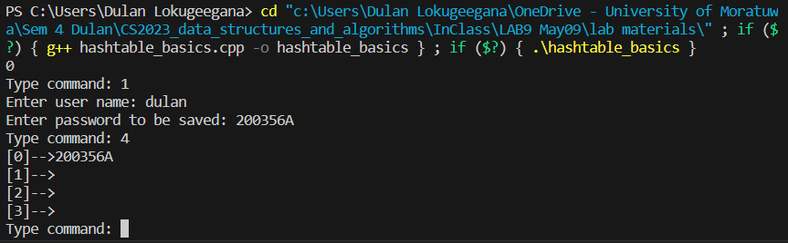

Q3.)

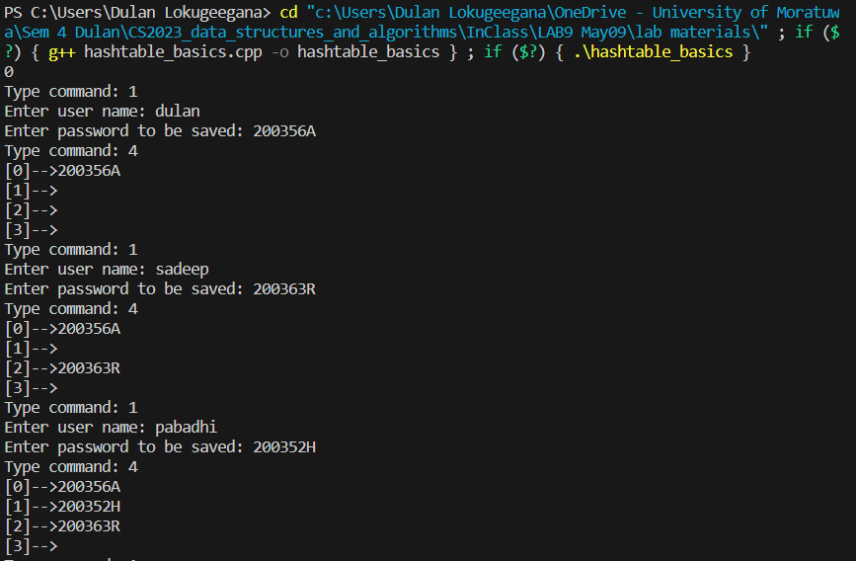

Q4.)

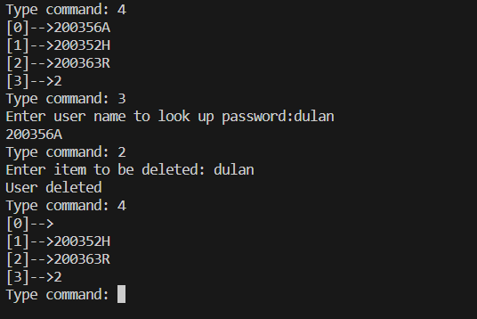

Q5.)

Most of the time there will be collisions as there are no more hash function to be check if there was a collision.

There are many ways we can change one is using chaining where a linked list is used, and we can add any amount data to the same location. The other method is using open addressing where it searches for another location if a collision is occurred.

**Section B**

Q2.)

Q3.)

Github link

<https://github.com/Dulan24/S4-CS2023-DSA-labs>